

micropile slope stabilisation
gatton clifton road

QLD P: 07 5500 5898
NSW P: 02 9620 4812
info@pcagroundeng.com.au | pcagroundengineering.com.au

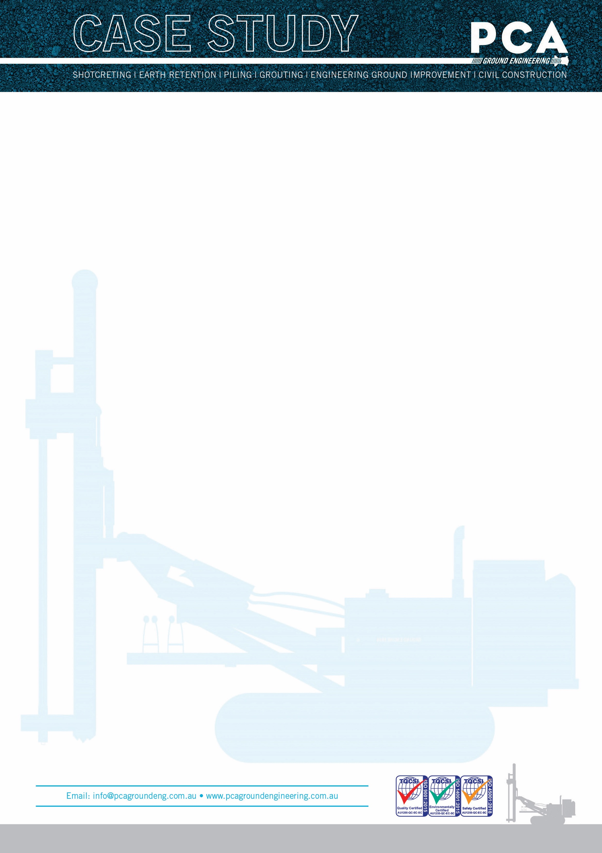

PROJECT TYPE: A-FRAME MICROPILE SLOPE STABILISATION
CLIENT: QUEENSLAND TRANSPORT AND MAIN ROADS
MAIN CONTRACTORS: McILWAIN CIVIL CONTRACTORS
PROJECT ENGINEERS: PCA GROUND ENGINEERING
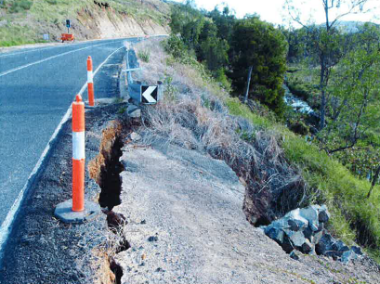
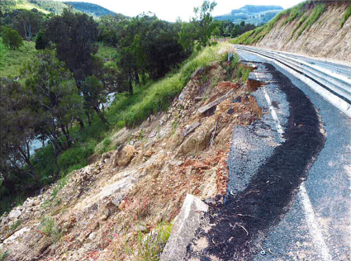

Project description and challenges
The area around Gatton Clifton Road has a history of slope instability due to the deep heavily weathered geological profile. The site is located approximately 20klm from the township of Gatton directly adjacent a steep slope running down to Ma Ma Creek. Significant rainfall between December 2010 and January 2011 caused major damage to the road infrastructure in the area and the road was closed to a single lane for over two years while Engineers worked on an appropriate solution.
Originally tendered as a soldier piled wall with 900mm diameter bored piles to varying depths along the 200m section of road, civil contractors bidding on the works faced significant challenges to support a piling rig on the unstable slope. Temporary works involving micropiles and steel plates to support the piling rig were designed which required $1million out of a total project budget of $6million.
PCA Ground Engineering had recently designed and constructed several A-Frame micropile structures for emergency works in the Sunshine Coast Hinterland in addition to a permanent structure for the Noosa City Council. These structures had proven themselves as a cost effective solution for supporting road assets with steep downslopes and deep slip problems. However, they had never been used in Australia for a state road authority for a permanent solution and no available Australian or State design standards were available.

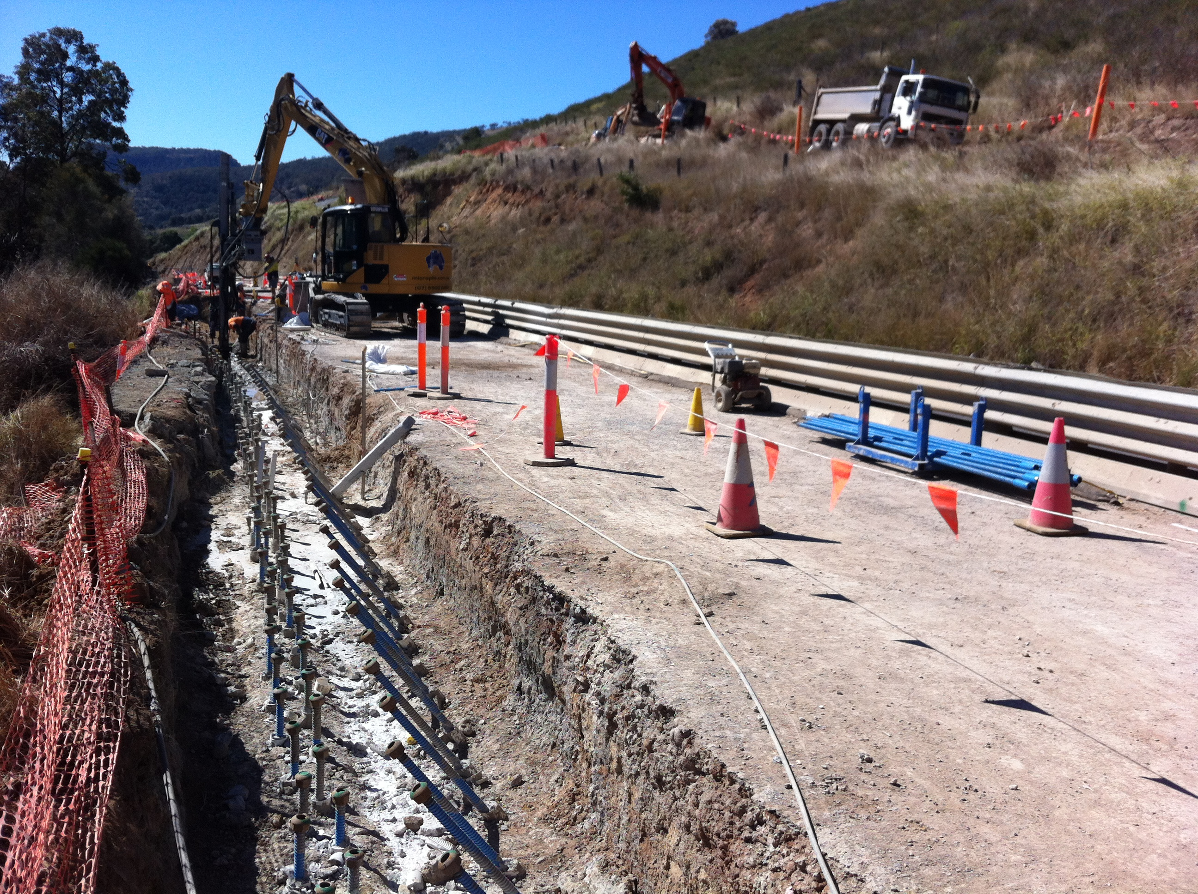

The Solution
Due to the time and cost savings compared to the bored pile design, PCA Ground Engineering was given the opportunity to work with our client and the Queensland Transport and Main Roads (TMR) Geotechnical Branch to test the suitability of an alternative micropiled A-Frame structure. After a rigorous design review process, TMR approved the alternative as a trial project.
The design was divided up into six different sections requiring six distinct design sections along the 200m project. Inclinometers were installed in two locations to monitor the structure and after several years and multiple significant rain events, measurements taken from the inclinometers confirm the structure is performing within the design parameters.
Unknown at the time of tender was the presence of previous stabilisation attempts in the form of gabions along the outer edge of the road alignment. These gabion structures were up to 3m in height and buried along the edge of the road alignment. Had the original bored pile wall been undertaken, significant time and cost wold have been spent removing the gabions and temporarily stabilising the cut to allow for the installation of the bored piles. The advantage of the micropile A-Frame equipment used during construction was the ability to drill through the gabion structures such that they could remain insitu.
The use of zero swing excavators enabled the works to be carried out from a single lane of traffic as opposed to the planned six week road closure for the bored pile design. This greatly reduced the impact on local stakeholders who relied on Gatton Clifton Road for access.
A letter of reference was provided to PCA’s client from the Superintendent praising the project with its cost and time savings. The project also won the prestigious TMR Innovation Award and a Civil Contractors Federation National Award.

