

CONTROLLED STIFFNESS COLUMNS
kingsford smith drive, brisbane

QLD P: 07 5500 5898
NSW P: 02 9620 4812
info@pcagroundeng.com.au | pcagroundengineering.com.au

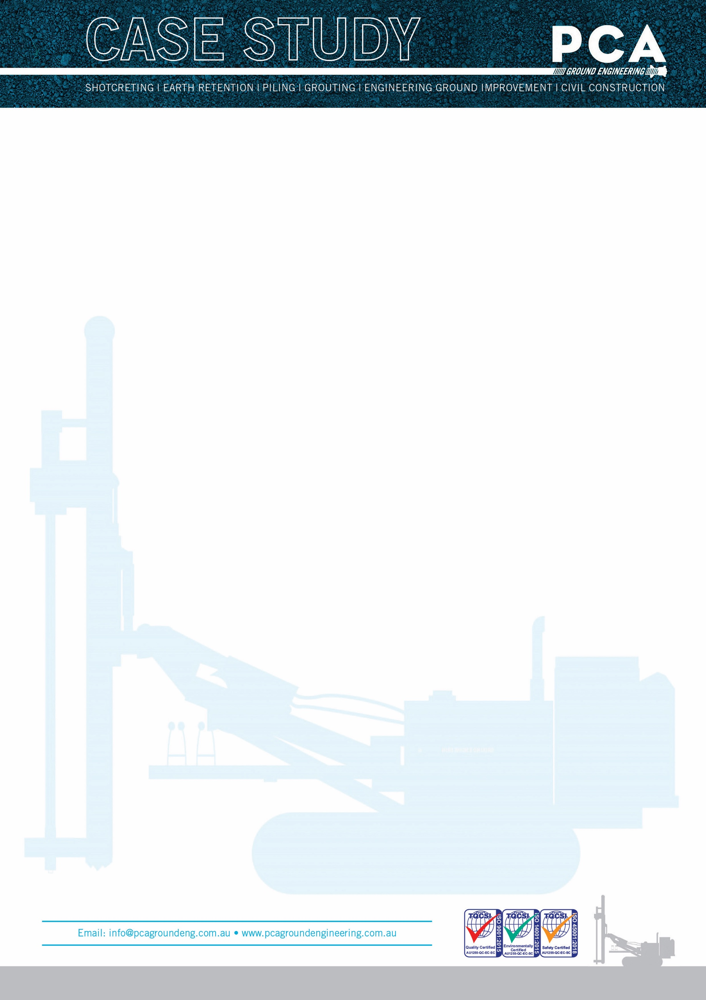

PROJECT TYPE: CONTROLLED STIFFNESS COLUMNS
CLIENT: LENDLEASE
MAIN CONTRACTORS: LENDLEASE

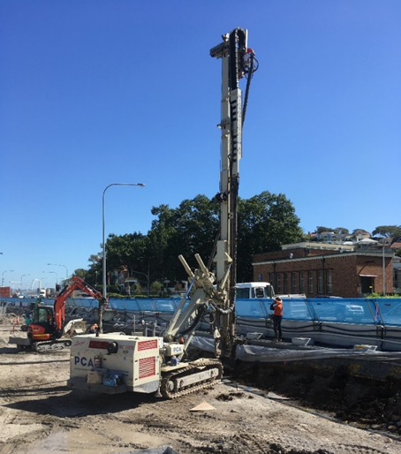

APPLICATIONS
Rigid inclusions increase the bearing capacity of the soil and reduce its compressibility. With rigid inclusions the advantages of piles and shallow foundations are economically combined.
This soil improvement in all construction sectors (residential, industrial and commercial buildings, embankments for highways and rail, harbour structures).
This method is most suitable for Compressible soils. Based on the initial compressibility of the soil the distance between rigid inclusion reinforcement elements is adapted depending on the allowable settlement of the structure.

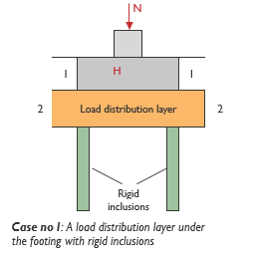
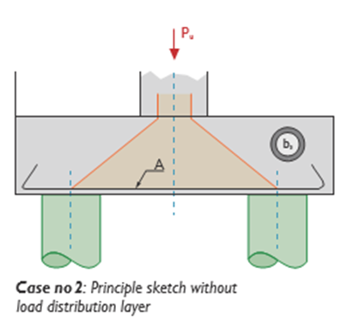

Rigid inclusions under footings without or with load distribution layer (only in seismic zones or with high horizontal loads)
The soil reinforcement with Controlled Stiffness Column rigid inclusions permits the increase of the bearing capacity of the soil and is suitable for the design of strip footings, generally with loads up to 0.25 MPa to 0.35 MPa in the case of a thin load distribution layer or in case of no load distribution layer.
Strip footings can be designed including arching in between the columns. If the dimensions of the strip footing are sufficient the horizontal forces may be taken by friction underneath the strip footing.
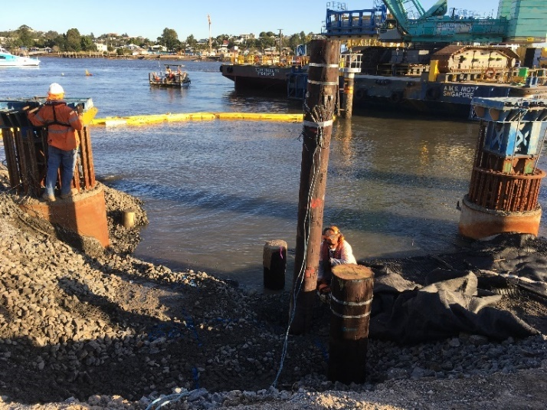
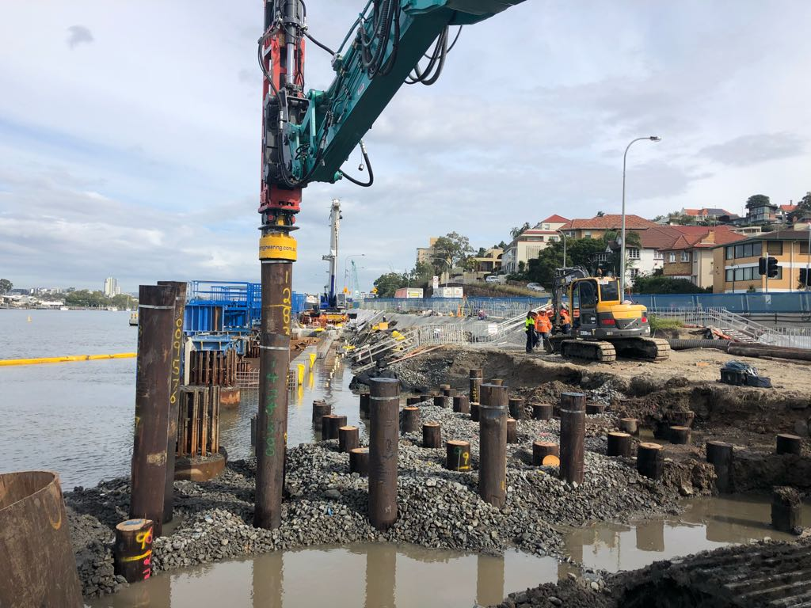

ADVANTAGES AND LIMITS OF THE METHOD
Soil reinforcement with rigid inclusions reduces settlements very efficiently. The settlements with this type of reinforcement can be reduced by a factor of 8 to 10 under high loads.
However it is necessary to take into account the hard point effect created by the inclusions on the superstructure. The strip footing must be designed like a slab on piles. In case of foundation slabs an additional bending moment has to be taken into account.
The additional bending moments depend on the thickness of the load distribution layer and of the compressibility of the soil in place, the grid of the inclusions and the service point loads (or distributed loads). This bending moment may be important for high uniform distributed loads or for racking combined with a thin load distribution layer.

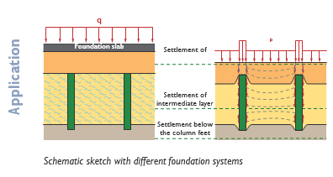

RIGIDS INCLUSIONS UNDERNEATH FOUNDATION SLABS
Underneath foundation slabs a load distribution layer is put in place between the rigid inclusions and the slab. The material between the top of the rigid inclusions and the foundation slab has to be compacted very carefully. The rigid inclusions are designed to act as a group. It is necessary to develop negative skin friction in the upper part of the inclusion just down to the neutral point (see the dashed line in the intermediate soil layer on the figure above). The applied stress is highest at the neutral point.
The Controlled Stiffness Column rigid inclusions are designed with the help of the usual parameters given in EN 1997-1. The design of this combined system of soil and group of rigid inclusions maybe calculated analytically (Priebe method for stiff columns) or with a finite element program.

PO Box 1605 Runaway Bay QLD 4216 • Phone: 07 5500 5898 Fax: 07 3041 6068
Email: info@pcacontracting.com.au • www.pcacontracting.com.au

QUALITY CONTROL
Quality control on site commences with accurate layout of column locations with the auger tool being centred at each staked location within an agreed tolerance. It is critical that work sequencing of the columns is planned and connected with design outcomes or surrounding asset can be damaged by the localised heave that an effective installation pattern will induce.
Each controlled stiffness column has an electronic log generated during the installation process.
- Column Number
- Diameter
- Length
- Start Time
- End Time
- Penetration Depth
- Pump Stroke Count
- Concrete or Grout Volume
- Crowd Pressure or Rotary Torque
PCA has developed data logging equipment and software for real-time monitoring and recording of all the key parameters, this system transmits all data in near real-time to a central database. In addition to PCA quality controls normal protocols such as concrete and grout is regularly sampled and cylinder tested for specification confirmation.

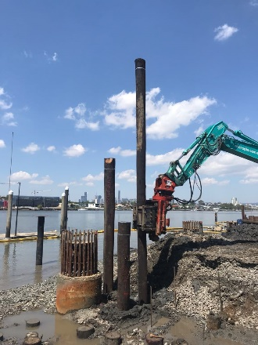
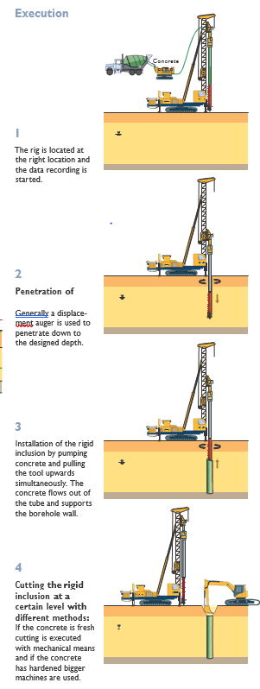
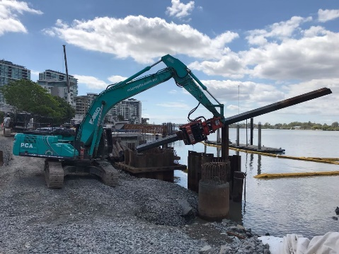

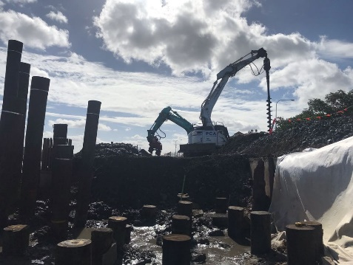
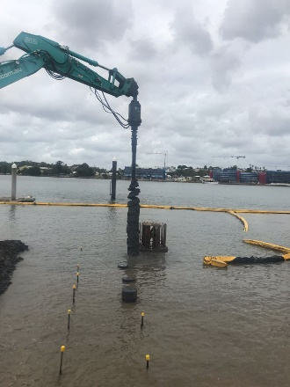

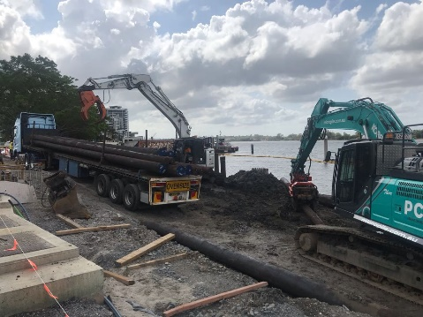
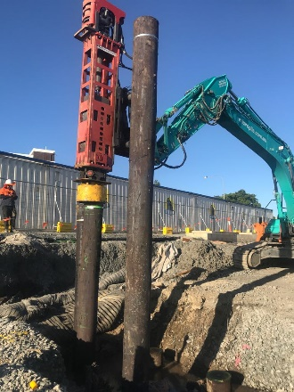
PO Box 1605 Runaway Bay QLD 4216 • Phone: 07 5500 5898 Fax: 07 3041 6068
Email: info@pcacontracting.com.au • www.pcacontracting.com.au

